Autopsy Forensic Analysis Case

General summary of the case

A possible data leak committed by the internal user johndoe is analyzed. For this, a forensic .E01 image extracted from a Windows Server 2019 system is examined. The goal is to identify traces of sensitive file manipulation, compression, browsing to transfer sites, and possible evidence deletion.
Tools used during investigation on segmented .E01 image

Autopsy Version 4.22.1 for Windows
Data Exfiltration Investigation

A file called users.txt contains sensitive information about 5 users' credentials.

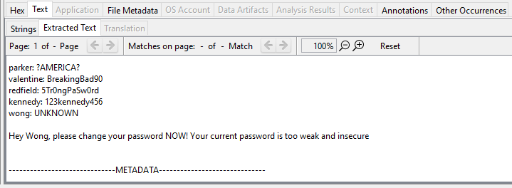
Location of the file users.txt --->

Data Sources
↓
windows-machine-evidence.E01_1 Host
↓
windows-machine-evidence.E01
↓
vol3 (NTFS / exFAT (0x07): 206848-103780351)
↓
users.txt

Files 7-ZipPortable_24.09.paf.exe and 7-ZipPortable_24.09.paf.exe:SmartScreen have been found in the Downloads folder of user johndoe.

Location of the files:
7-ZipPortable_24.09.paf.exe
7-ZipPortable_24.09.paf.exe:SmartScreen
Data Sources
↓
windows-machine-evidence.E01_1 Host
↓
windows-machine-evidence.E01
↓
vol3 (NTFS / exFAT (0x07): 206848-103780351)
↓
Users
↓
johndoe
↓
Downloads
↓
7-ZipPortable_24.09.paf.exe
7-ZipPortable_24.09.paf.exe:SmartScreen

---> Details about file: 7-ZipPortable_24.09.paf.exe

File Metadata:

Modified: | 2025-06-04 16:31:02 EEST
Accessed: | 2025-06-04 16:31:02 EEST
Created: | 2025-06-04 16:30:47 EEST
Changed: | 2025-06-04 16:31:34 EEST
MD5: | 317121ba1d6606dd612558d8c17b41ae
SHA-256: | c39d6965c27638ce1dbc4d306708ad83a3a35af043785ba8e4721d36aed282d4
Hash Lookup Results: | UNKNOWN
Internal ID: | 12146
Downloaded From: | https://portableapps.com/redir2/?a=7-ZipPortable&s=s&d=pa&f=7-ZipPortable_24.09.paf.exe

---> Details about file: 7-ZipPortable_24.09.paf.exe:SmartScreen

File Metadata:

Modified: | 2025-06-04 16:31:02 EEST
Accessed: | 2025-06-04 16:31:02 EEST
Created: | 2025-06-04 16:30:47 EEST
Changed: | 2025-06-04 16:31:34 EEST
MD5: | 4047530ecbc0170039e76fe1657bdb01
SHA-256: | 82254025d1b98d60044d3aeb7c56eed7c61c07c3e30534d6e05dab9d6c326750
Hash Lookup Results: | UNKNOWN
Internal ID: | 12148
Web Downloads

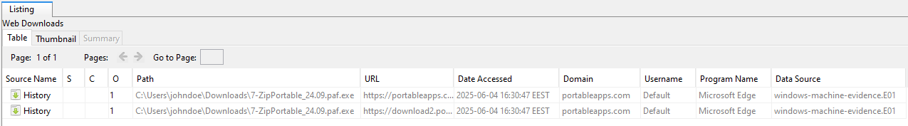
Web History
History of visited websites:

Gmail
WeTransfer
MEGA
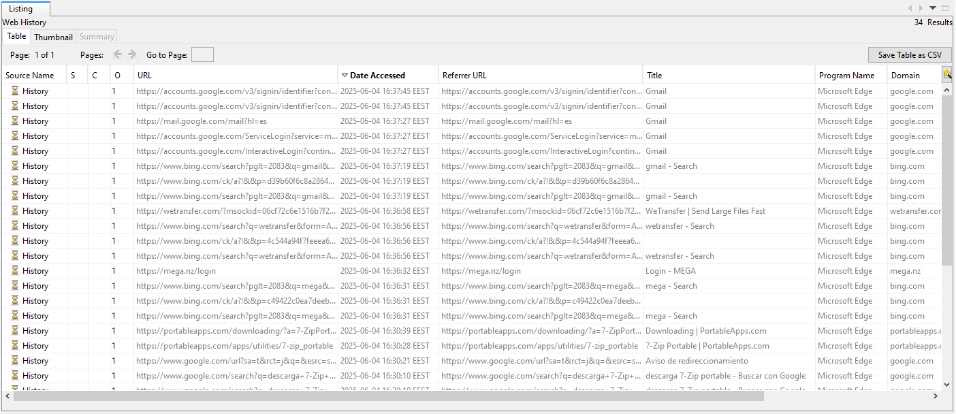

Conclusion

---> Files:
7-ZipPortable_24.09.paf.exe
7-ZipPortable_24.09.paf.exe:SmartScreen
have been found in the Downloads folder of user johndoe.

Note: 7-ZipPortable_24.09.paf.exe doesn't need installation, doesn’t modify the host computer's registry or file system and can run directly.

---> A copy of the file users.txt has been found in the johndoe\Documents folder that contains sensitive information.

---> The user johndoe visited: Gmail, WeTransfer and MEGA.

WeTransfer is an online file transfer service that allows users to share large files easily, without needing to create an account.

MEGA allows users to store files in the cloud, accessible from any device with an internet connection.

There is evidence of a possible data leak of file users.txt that contains sensitive information on the websites or e-mail: Gmail, WeTransfer and MEGA.

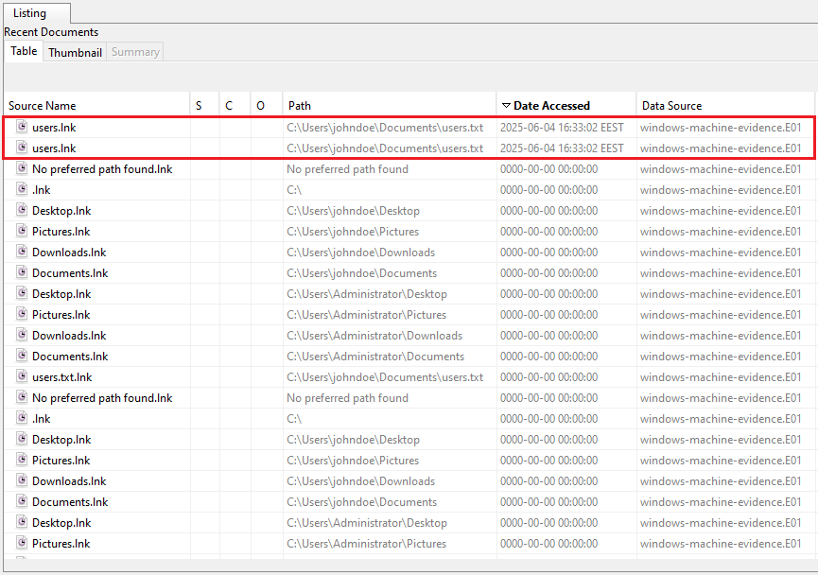

Bonus Findings

File name: flag.txt

Data Sources
↓
windows-machine-evidence.E01_1 Host
↓
windows-machine-evidence.E01
↓
vol3 (NTFS / exFAT (0x07): 206848-103780351)
↓
Users
↓
Administrator
↓
Desktop
↓
flag.txt

